Ruby Programming Language

Aisha Jackson
Spelman College
350 Spelman Lane
Atlanta, GA 30314
ajacks87@scmail.spelman.edu

Simone Smarr
Spelman College
350 Spelman Lane
Atlanta, GA 30314
ssmarr@scmail.spelman.edu

ABSTRACT
In this paper, we describe the essential information regarding the Ruby programming language. We cover the history, structure, uses and benefits of the language, as well as the applications of the language.
General Terms
Programming Website Language Object Oriented Procedural Functional LISP Perl
Keywords
Object-oriented dynamic programming Matz Ruby on Rails

INTRODUCTION
“Ruby is a dynamic, open source programming language with a focus on simplicity and productivity. It has an elegant syntax that is natural to read and easy to write.” (Official Ruby Site [12]) Ruby is a object-oriented programming language that gets some influence from other languages such as Python and PHP. The language has been growing in popularity because of its simple structure that still allows for complex programs. It also has gained popularity through the Ruby on Rails framework, which allows for web application development.

BACKGROUND
The Ruby Programming language originated in Japan during the mid 1990s and was developed and designed by Yukihiro “Matz” Matsumoto. Matsumoto is a Japanese computer scientist and software programmer. Matsumoto discussed the possibility of an object oriented scripting language with certain features. For example, he was looking for a simple syntax, object oriented, iteration and closure, exception handling, garbage collection and portability.

Genealogy
Ruby was born in February 23, 1993 but in Dec 21, 1995, Ruby 0.95 was released. This version of Ruby came with object oriented programming, inheritance, iterators, exception handling, and garbage collection. In December of 1996, Ruby 1.0 was released followed by Ruby 1.3 in 1999 and Ruby on Rails in 2005. The improvement also included duck typing, fully qualified names, native YAML support, WEBrick, String IO, open Uri, PP ruby, MVC framework coded with Ruby and the ability to run Unix commands. In 2007, Ruby 1.9.1 was released which had significant speed improvements, new methods, new syntax, rubyGems, new socket API, random number generators, regular expression improves, encoding support, and string formatting. After Ruby 1.9.1, Ruby 1.93 was released in 2011, Ruby 2.0 in February of 2013 and Ruby 2.1.2 in May 2014. The newest versions of Ruby include speed improvements, refinements, keyword arguments, new regular expressions engine, optimized garbage collection, and built in syntax documentation.

GENERAL PROPERTIES

Overview
Ruby is a dynamic programming language with a complex grammar and a core class library. Ruby gets inspiration from Lisp, Smalltalk, and Perl but uses grammars that are easy for C and Java programmers. Ruby is an object-oriented language that is suitable for procedural and functional programming styles. Ruby contains metaprogramming capabilities, which is the process by which the program manipulates other programs or itself.

Programming Design
Object-oriented programming is a programming design that contains objects that have attributes and their associated procedures known as methods. Objects are instances of classes and are used to interact with one another. Ruby is an object-oriented programming language that allows the user to create objects based on the concepts it contains. Ruby can then act upon and understand the relationships between the objects in any way the user defines. Ruby objects may possess any number of instance variables but they only expose methods to the outside.

Evaluation
“An operator is a token in the Ruby language that represents an operation to be performed on one or more operands.” For example, for numeric values, there are the +, -, *, and / operators with the normal multiplication, division, addition and subtraction precedence. The operands are normal expressions and the operators combine the operands. There are also number comparison operators in Ruby as pictured in Table 3-2. The arity of an operator is the number of operands it operates on. Unary operators have a single operand. Binary operators have two operands. Ternary operators have three operands. Operator precedence affects the order of evaluation of an expression and only specifies the default order of evaluation. The left and right associativity of an operator specifies the order of evaluation when the same operator appears next to each other in an expression. Ruby also implements some operators as methods, which allow classes to define new meanings for those operators.

Namespacing
The modules in Ruby help to solve the problems of code name conflicts by providing namespaces that can contain any number of classes, methods, and constants and allow the user to address them directly. For example, a module can group methods to encode and decode binary. The method names can be changed to prevent namespace collisions with other decode and encode methods. Additionally, the user can use classes as namespaces and make libraries in Ruby. The modules, including classes, can be nested which means the namespaces can be nested.

Data Types
Ruby contains classes, which are all of the data types. The five classes for representing numbers are integer, float, Complex (standard library), BigDecimal (standard library) and rational (standard library). All number objects in Ruby are instances of Numeric. All integers are instances of Integer and then are instances of Bignum and Fixnum depending on the number of bits the value has. Real numbers within the Float class use the floating-point representation. The Complex, BigDecimal, and Rational classes are not built-in but are distributed with Ruby as part of the standard library. The complex class represents complex numbers. BigDecimal represents real numbers with decimal representation. The Rational class represents rational numbers, which is one integer, divided by another.
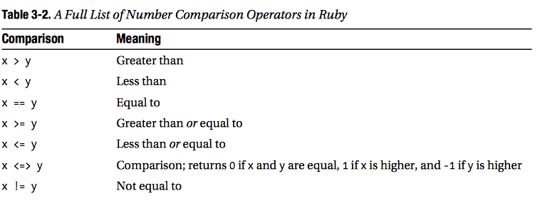
Ruby contains integer literals, which are a sequence of digits. The floating-point literal is an optional sign followed by one or more decimal digits, a decimal point, one or more additional digits, and an optional exponent. An exponent begins with the letter e or E and is followed by an optional sign and one or more decimal digits.
Cooper, Peter. Beginning Ruby (n.d): n pag. Web.
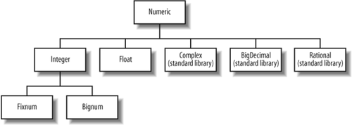
All numeric types in Ruby are able to perform standard operations, addition, subtraction, multiplication and division. Ruby uses the ** operator for exponentiation.
Flanagan, David, and Yukihiro Matsumoto. The Ruby Programming Language. Beijing: O'Reilly, 2008. Web
Text is represented in Ruby by objects of the String class. The string literals are enclosed in single quotes and the text within the quote marks is the value of the string. If you need to place an apostrophe within a single-quoted string literal, place a backlash in front of it. Double quoted string literals are able to support backslash escape sequences like \n for newline, \t for tab, and \” for quotations mark that do not end the string. Double quoted string literals may also contain string interpolation.
Single characters can be included in a Ruby program by preceding the character with a question mark. It does not have a special class to represent single characters.
The string class has several operators for manipulating strings. The + operator puts together two strings and returns the result as a new String object. The << operator adds its second operand to its first.
An array is a sequence of values that allows values to be accessed by their position or index in the sequence. In Ruby, the first value in an array has index 0. The size and length methods return the number of elements in an array. The elements of an array do not need to be in the same class and they can be changed at any time. Arrays are also resizable and you are able to add elements to them. An array literal is a comma-separated list of values, enclosed in square brackets. The array class borrows the Boolean operators | and & and uses them for union and intersection.
A hash is a data structure that maintains a set of objects called keys and associates a value with each key. Hashes are also known as maps because they map keys to values. A hash literal is written as a comma-separated list of key/value pairs, enclosed within curly braces. Keys and values are separated with a two-character “arrow”. Ruby hashes are implemented with hash tables.
A range object represents the values between a start value and an end value. Range literals are written by placing two or three dots between the start and end value. If two dots are used, the range is inclusive and the end values are part of the range. If three dots are used, then the range is exclusive and the end value is not part of the range.
True and false are two Boolean values. Nil is a special value to indicate the absence of value. Each of these keywords evaluates to a special object. There is no Boolean class in Ruby.
Lastly, in Ruby, all objects inherit from a class named Object and share the methods defined by that class. When you work with objects in Ruby, you are really working with object references.

Parameters
A class or an object in Ruby can be followed by a period and the name of the method. The method can take one argument, which is a discrete item of data being passed to a method, also called a parameter. Parameter passing is the way in which parameters are transmitted to and/or from called subprograms. In ruby parameters are passed by value meaning that the value of the actual parameter is used to initialize the corresponding formal parameter, which then acts as a local variable in the subprogram, this implementing in-mode semantics.⁹ Ruby’s interpreter uses top-down parsing. This means that it reads the code from left to write, top to bottom, just like English. This is also true for the control flow; the logic in Ruby must flow from top to bottom in order. Although Ruby methods use pass by value, the value of the reference of the object can be passed to the Ruby methods. Ruby also uses the pass by object sharing.

Control Flow
Everything in Ruby is an object, anything can be given instance variables or methods. Ruby’s control structures include conditional branches (such as if, unless, if-elsif-else, short-if & case expressions), loops, (such as while and until statements) and exception handling. If statements use the if keyword to check if an expression is true. If it is true, a statement or compound statement (block) is executed. The unless statement is the opposite of an if statement. The unless statement executes the code if the conditional is false. Both if and unless statements can include an else clause that executes if the requirement of the statement is not met. There is also the shorthand short-if expression is meant to help save space. It is useful for string concatenation but is suggested only for minor tasks. Case statements are a concise version of a long if-elsif-else statement. It can be used to evaluate multiple statements and execute a statement for multiple conditions. The while loop in Ruby executes a code block while the corresponding expression is true. The until is the opposite of the while statement, it executes the code block until the corresponding expression is true.

Proc, Blocks and Methods
Ruby borrowed features from functional programming languages, which are implemented through Proc objects, blocks and methods. Methods are used in Ruby to create subroutines and they automatically return the value of the last statement executed. Default values can be included in the method definition to set a value for a parameter if one is not specified when the method is called. An asterisk can also be put after the last parameter in a method definition which tells the program that more parameters can be passed and they will be put into an array. Blocks in Ruby allow a programmer to attach a closure to any method that describes how that method acts. Blocks add flexibility to the language and are popular with programmers that are used to imperative languages. Proc objects are blocks of code that have been bound to a set of local variables and can be called in different contexts. When it is called in different contexts the Proc object still has access to those variables.

Variables & Syntax
Ruby uses dynamic type binding, which means variables are bound to a type when assigned a value in an assignment statement. In Ruby all variables are references and do not have types. Since all data in Ruby are objects, any variable can reference any object. Ruby is also considered a transparent language because it has an easy to follow syntax and it simply completes tasks. The syntax of Ruby helps programmers to easily express their ideas as code directly without worrying about how to format it for Ruby. This adds to the readability of ruby and makes it easier to write as well.

SPECIAL PROPERTIES

Overview
Ruby is a language that was influenced by multiple programming languages. Therefore it has some great features that resemble those of other languages but it also has features that set it apart from other languages. It also is a language that continues to grow in popularity as more people become inclined to learn Ruby.

Ruby on Rails
One major implementation of Ruby is through Ruby on Rails. Rails is a web application development framework that is written in Ruby. It was designed to simplify the web application development process by allowing programmers to write less code while accomplishing more. The philosophy of Ruby on Rails is based on the Convention over Configuration and Don’t Repeat Yourself principles. Convention over Configuration means the developer only needs to specify unconventional aspects of the application. Ruby on Rails conventions lead to less code and less repetition. Don’t Repeat Yourself means that information is located in a single unambiguous place. Rails was first released in July 2004. Rails has grown in popularity since its first release; more consumer web firms now use it to build scalable web applications. Some popular sites that use Ruby on Rails are Hulu, GitHub and Basecamp. Rails provides database storage, business logic and efficient testing for web developers. Everything in Rails is defined in a single, unambiguous place. The way the Ruby programming language can be used to easily create web applications without first needing a deep understanding of development is a big contribution to technology from Ruby.
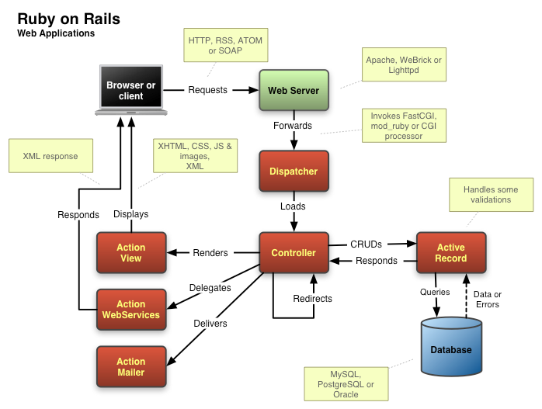
Fig 4.1 Ruby on Rails structure (binaryhash.com)

Ruby Features
Ruby has four levels of variable scope; global, class, instance and local. Ruby uses very limited punctuation and usually prefers English keywords, but some punctuation is used. Ruby needs no variable declarations, it uses simple naming conventions to denote the scope of variables.: (1) var could be a local variable. (2) @var is an instance variable. (3) $var is a global variable. The use of symbols in this case adds to Ruby’s readability. Ruby also allows for operator overloading which is a case of polymorphism. One way that Ruby differs from Python and Perl is that it keeps all of its instance variables private to the class and only exposes them through accessor methods. With metaprogramming, accessor methods can be created in one line unlike in C++ and Java. Another interesting feature of Ruby is that the syntax is capitalization sensitive; capitalized variables are constants. There is also an operator difference in Ruby when it comes to conditional expressions. In Ruby and does not bind tighter than or which is a difference from most languages. Booleans in Ruby are handled strictly. Everything is considered true except false and nil.

Uses
Ruby was designed as a general purpose scripting language. The fact that it was designed for general use, it is applicable for use for many different applications. Through Rails, Ruby can be used for web applications. Ruby is also used for web servers, graphing libraries, picture recognition engines, threaded database servers and desktop GUI applications.

ACKNOWLEDGMENTS
We thank Google and our textbook for assisting us through the research process. We also thank Thoughtworks for introducing us to Ruby.

REFERENCES –
- Cooper, Peter. Beginning Ruby (n.d): n pag. Web.
- Flanagan, David, and Yukihiro Matsumoto. The Ruby Programming Language. Beijing: O'Reilly, 2008. Web.
- "The Many Interpreters and Runtimes of the Ruby Programming Language." Total Engineering Blog. N.p., n.d. Web. 29 Oct. 2014.
- Morin, Michael. "What Is Ruby?" About Technology. N.p., n.d. Web. 29 Oct. 2014.
- Zimdars, Jason, and Ruby Community. "Ruby." Programming Language. Web. 29 Oct. 2014. <https://www.ruby-lang.org/en/>.
- Gayle, Marc. "A Beginner's Guide To Ruby." Smashing Magazine. Smashing Magazine, 24 May 2012. Web. 29 Oct. 2014.
- Kehoe, Daniel. "What Is Ruby on Rails?" · RailsApps. Github, 11 Oct. 2013. Web. 29 Oct. 2014.
- Talim, Satish. "Rubylearning.com A Ruby Tutorial." Learn Ruby. N.p., 1 Jan. 2014. Web. 29 Oct. 2014.
- "Ruby (programming Language)." Wikipedia. Wikimedia Foundation, 19 Nov. 2014. Web. 23 Nov. 2014.
- Sebesta, Robert W. Concepts of Programming Languages. 10th ed. Boston: Pearson Addison Wesley, 2012. Print.

"Ruby (programming Language)." Wikipedia. Wikimedia Foundation, 19 Nov. 2014. Web. 23 Nov. 2014.
Flanagan, David, and Yukihiro Matsumoto. The Ruby Programming Language. Beijing: O'Reilly, 2008. Web.
Flanagan, David, and Yukihiro Matsumoto. The Ruby Programming Language. Beijing: O'Reilly, 2008. Web.
Cooper, Peter. Beginning Ruby (n.d): n pag. Web.
Flanagan, David, and Yukihiro Matsumoto. The Ruby Programming Language. Beijing: O'Reilly, 2008. Web.
Flanagan, David, and Yukihiro Matsumoto. The Ruby Programming Language. Beijing: O'Reilly, 2008. Web.
Cooper, Peter. Beginning Ruby (n.d): n pag. Web.
Flanagan, David, and Yukihiro Matsumoto. The Ruby Programming Language. Beijing: O'Reilly, 2008. Web.
Sebesta, Robert W. Concepts of Programming Languages. 10th ed. Boston: Pearson Addison Wesley, 2012. Print
Zimdars, Jason, and Ruby Community. "Ruby." Programming Language. Web. 29 Oct. 2014
Zimdars, Jason, and Ruby Community. "Ruby." Programming Language. Web. 29 Oct. 2014
Talim, Satish. "Rubylearning.com A Ruby Tutorial." Learn Ruby. N.p., 1 Jan. 2014. Web. 29 Oct. 2014.
Gayle, Marc. "A Beginner's Guide To Ruby." Smashing Magazine. Smashing Magazine, 24 May 2012. Web. 29 Oct. 2014
Kehoe, Daniel. "What Is Ruby on Rails?" · RailsApps. Github, 11 Oct. 2013. Web. 29 Oct. 2014
Talim, Satish. "Rubylearning.com A Ruby Tutorial." Learn Ruby. N.p., 1 Jan. 2014. Web. 29 Oct. 2014
"Ruby (programming Language)." Wikipedia. Wikimedia Foundation, 19 Nov. 2014. Web. 23 Nov. 2014

